How to Create A Parent Access Account
In order to create a Parent Access account, you must have an Access Account ID and Access Password for each student you wish to add to your account. This information will be supplied by your school.

Click the URL for your student's school https://powerschool.cbalincroftnj.org/public

Create Parent/Guardian Account
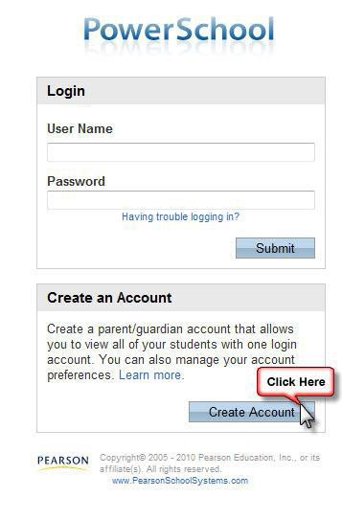
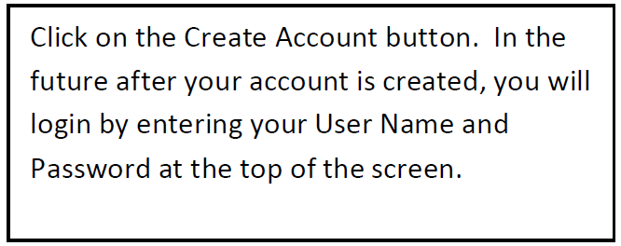
Enter the following information:
- First Name
- Last Name
- Email address
- Desired User Name - This is the name you will use to access the system in the future. (Do not use your email address.)
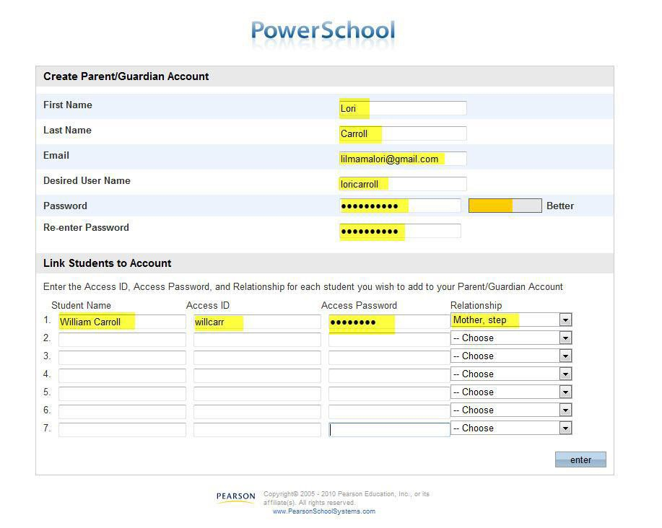
- Password and Re-Enter Password -The gauge on the right lets you know the strength of your password choice.

Link Students to Account

The following information (provided by your school) is required for each student you wish to add to your account:
- Student's name
- Access ID
- Access Password
- Your relationship to the student

Click Enter when done.
.

When complete you should get the Congratulation! Your new Parent/Guardian Account has been created screen (see below).
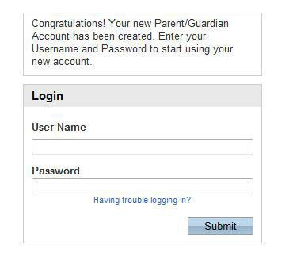
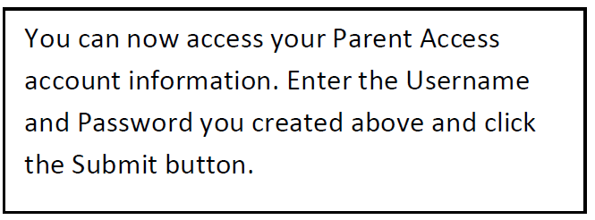

Adding Students to Your Account

Click the Account Preferences icon.
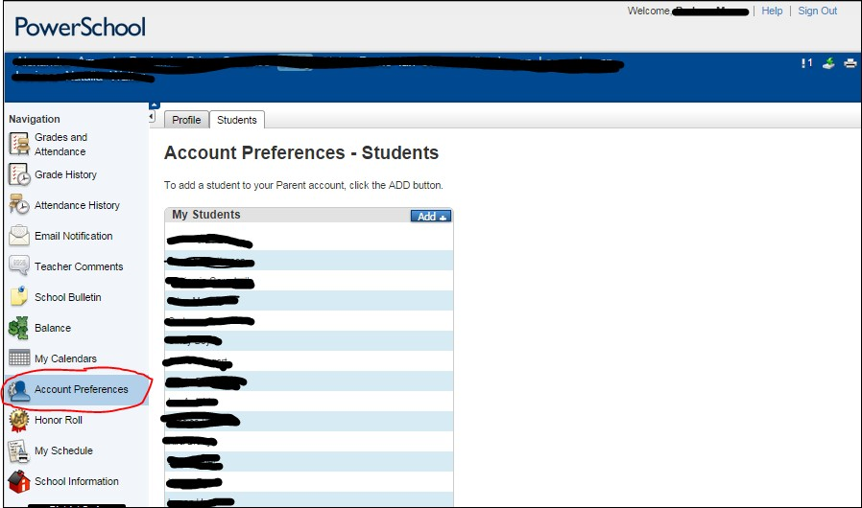

The Profile tab allows you to change your First Name, Last Name, Email address, User Name (used to access Parent Access) and Current Password.
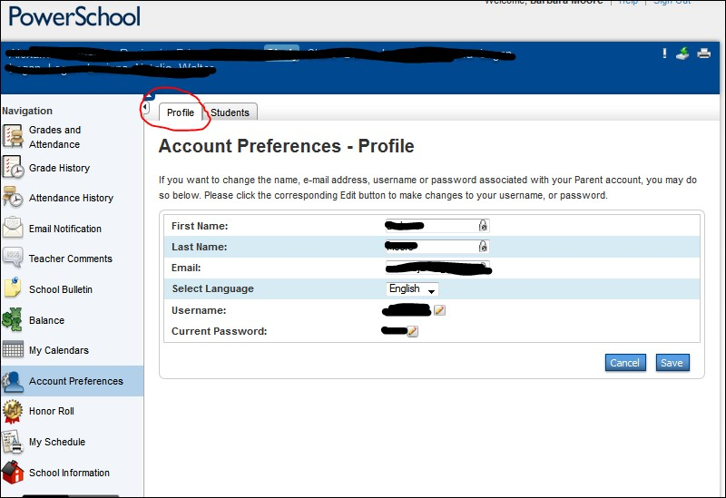
To change your username or password, use the pencil icon.

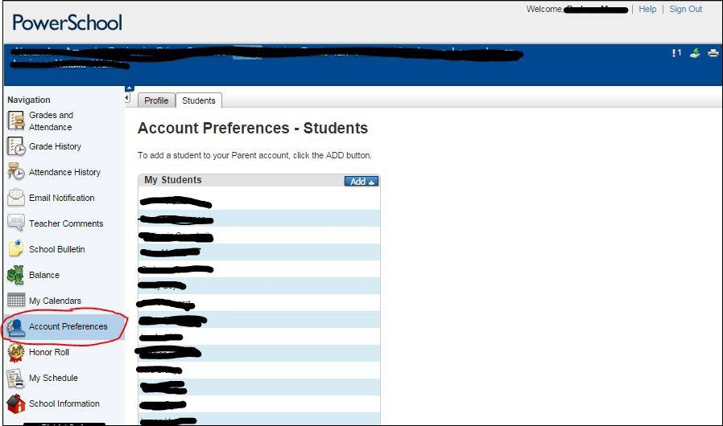
Click the Students tab to add another student to your account. Students can attend different schools; however, you must have their Access ID and Access Password to add them to your account.

Enter the student's Name, Access ID, Access Password and your relationship to the student. Click the Submit button to add the student to your account.

The new student has been added to your account. Each of you students will have their own tab at the top of the page. Click the student's name and the page icon containing the data you wish to see.

To keep your student's data secure, Logout when you are finished.

