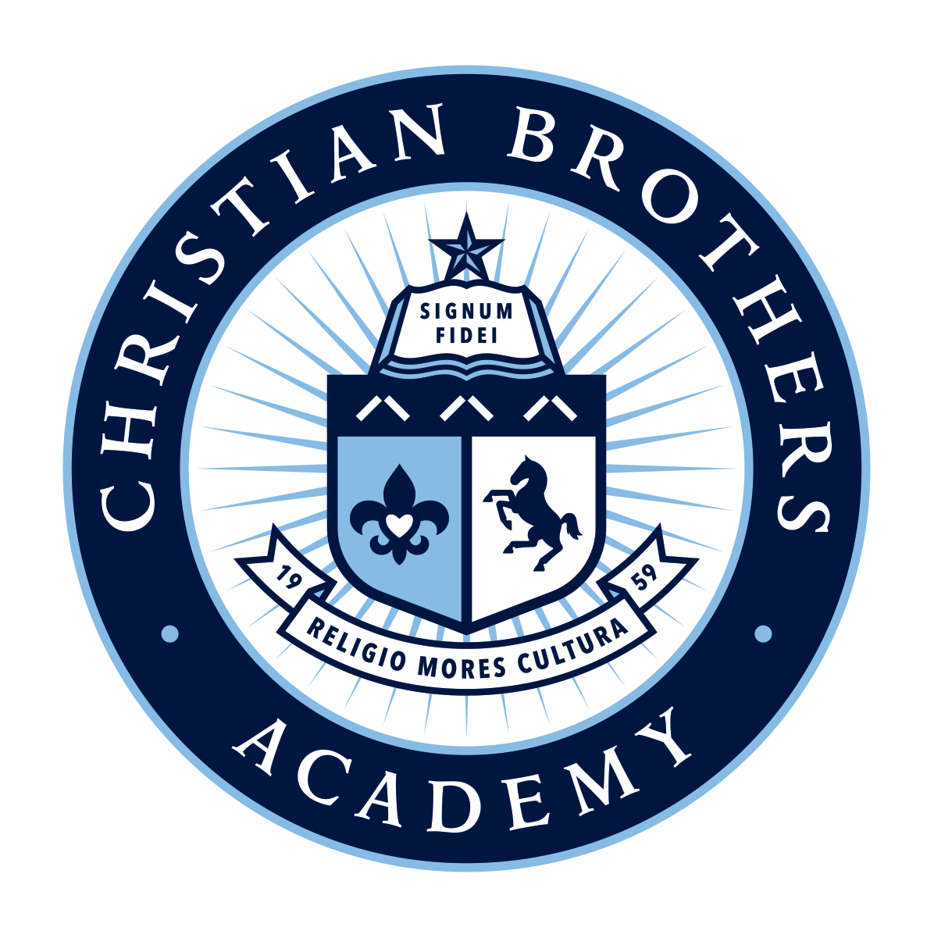 | CBA Fathers’ Club  Christian Brother's Academy • Lincroft • New Jersey

Meeting Agenda
Tuesday – September 17, 2019

- Call to Order/Opening Prayer: M. Anderko / Br. Frank Byrnes
- Approval of Minutes: September 2019 Rich Settino / Bill Coughlin
- Guest Speakers Principal Fales / A.D. Chiaravalloti
- Financial Report: James Sullivan
- Dinner
- Committee Reports: (Overview) Gary Krall
  - Brother Andrew Golf Outing: (10/1/19) Kevin Golding
- Recap of Event
  - Father / Son Service (3rd Saturday of the Month) Kevin Gibson
  - Hospitality (Monthly Meetings) Vincent Fasano
  - Communications David Tierney
  - Blue Coats Rich Settino
    - Sign Up Genius for all upcoming Events
  - Father / Son Outings James Sullivan
Next Event – Navy / SMU Football Trip 11/23/2019
  - Father / Son Communion Breakfast M. Knuecker / J. Sullivan
  - End of Year Family Picnic Gary Krall
  - Father / Son Golf Outing Kevin Gibson
  - Alumni Updates Br. Frank Byrnes
- New Items: Annapolis – Navy Football November 23, 2019 – Ticket Information
- Next Meeting – Tuesday, November 12, 2019– 7:00 PM Alumni Hall
Speaker(s): Current Concerns with Vaping. Nirav Shah DO. Medical Director of Critical care James Matera DO. Chief Medical Officer. CentraState Medical Center
- Closing Remarks: Mark Anderko
Upcoming Calendar of Events:
Sat., Oct. 19, 2019 Forever CBA Campaign– Public Introduction of Capital Campaign
Sat., Oct. 26, 2019 Entrance exam, 8 am, help with parking
Wed., Feb. 12, 2020 Honors Convocation/ NHS Induction 7 pm, help with parking
Tues., May 19, 2020 Baccalaureate liturgy, St. Mary's, Middletown, 7 pm, ushering
Thurs., May 21, 2020 Grandparents Day liturgy, 7:30 am, help with parking and ushering
Thurs., May 21, 2020 Graduation, Brookdale CC, 6 pm, ushering

